TDA – Chassis assembly

The buggy is now fully assembled, with most of the wiring being completed.

We have had a few minor setbacks within the buggy formation as we have come along, one of those being the motor hole dimensions were off slightly so after some SolidWorks redesigning and repositioning, we moved the holes so that the dimensions were correct. Now all elements fit into the buggy in an accurate way.

We have also decided to reposition some of the components in comparison to the original buggy diagram. Moving the motor drive board onto the second layer, the battery back underneath the frame between the motors and the microcontroller on the top layer of the buggy. This ensures more stability for the buggy, as well as ensuring that the microcontroller is accessible during testing.

The battery pack is attached on the bottom via Velcro and hot glue for ease of disassembly to recharge batteries when necessary.

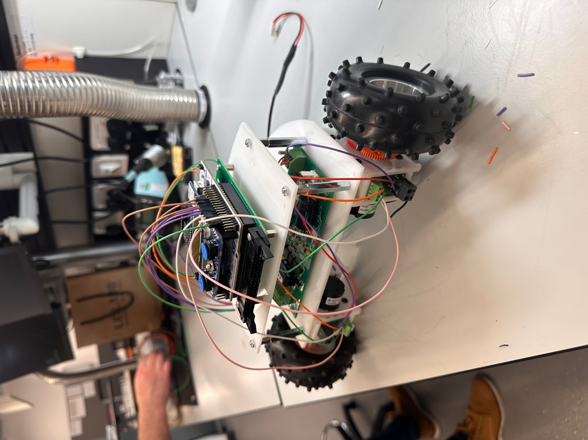

These two pictures demonstrate the buggy fully assembled with both layers connected. As well as the switch for the batteries being in an ideal place for the connections to the motor drive board below.